**A  
Project Report  
on**

**Parking Management System**

**Submitted to**



**DEPARTMENT OF COMPUTER SCIENCE AND ENGINEERING  
U.V.PATEL COLLEGE OF ENGINEERING  
GANPAT UNIVERSITY**

**OCTOBER 2017**

**Submitted By**

|  |  |
| --- | --- |
| ***Divit Vasu*** | 16012121006 |
| ***Deep Patel*** | 16012121019 |
| ***Harsh Patel*** | 16012121009 |
| ***Preet Merchant*** | 16012121014 |
| ***Anand Agrawal*** | 16012121002 |
| ***Jigyasa Kashyap*** | 16012121012 |

*Application Development (AD-1)*

*Project Document*

***Parking Management System***

*Date of submission:*

*2-11-2017*

* ***Certificate of Completion:***

*This is to certify that the project titled “Parking Management System” has been worked upon satisfactorily, by the following students of 3rdsemester (B.Tech, Computer Science and Engineering) for partial fulfillment of the subject “Application Development-I” during July-2017 to October-2017 under the guidance of Prof. Mitul Patel and Prof. Hirav Shah.*

Name of Students:

|  |  |
| --- | --- |
| *Divit Vasu* | 16012121006 |
| *Deep Patel* | 16012121019 |
| *Harsh Patel* | 16012121009 |
| *Preet Merchant* | 16012121014 |
| *Anand Agrawal* | 16012121002 |
| *Jigyasa Kashyap* | 16012121012 |

Date: 2/11/2017  
Place: Ahmedabad  
Internal Guide : Prof. Mitul Patel

HOD : Dr. Hemal Shah

* ***Table of Contents…***

|  |  |  |
| --- | --- | --- |
| ***Sr.no*** | ***Contents*** | ***Page no.*** |
| *1.* | *Certificate of Completion* | *2* |
| *2.* | *Acknowledgement* | *4* |
| *3.* | *Problem Definition* | *5* |
| *4.* | *Introduction to the project* | *5* |
| *5.* | *Scope of the project* | *6* |
| *6.* | *Description of Functionalities* | *6-7* |
| *7.* | *Flow Chart* | *8-9* |
| *8.* | *E-R Diagram and database design* | *9-11* |
| *9.* | *Hardware and resources required* | *12* |
| *10.* | *Timeline and proposed Workflow* | *12-13* |
| *11.* | *Survey Form and Analytics (Attached at the end of the report)* | *14* |
| *12.* | *Bibliography* | *14* |

* ***Acknowledgement:***

*We owe a debt of gratitude to Prof. Mitul Patel and Prof. Hirav Shah for the vision and foresight onto this project, which inspired us to work towards its completion for the first segment.*

*We would hereby like to make the most of the opportunity by expressing our sincere thanks and honor to our professors, whose teachings gave us conceptual understanding and clarity of comprehension, which ultimately credited in aiding us to sail through the project.*

*We are particularly indebted to them for their constant association during the course of this work (SEM III) and their overwhelming attitude and utmost patience has enabled us to work to the fullest.*

*We would also like to take this opportunity to express our sincere appreciation to the college for giving us this opportunity of exploring and creating at an early stage.*

**Sincere thanks on behalf:**

1. Divit Vasu (16012121006)
2. Deep Patel (16012121019)
3. Harsh Patel (16012121009)
4. Preet Merchant (16012121014)
5. Anand Agrawal (16012121002)
6. Jigyasa Kashyap (16012121012)

* ***Project Definition:***

Our project on formulating a functional “Parking Management System”, is mainly aimed at providing a convenient and hassle-free access to available parking spots near a person’s point of interest (public domain) or in Malls, Offices, Universities etc. (private domain).

If implemented, we aim to solve the current chaotic system, which could enable us to prevent traffic jams to an extent and most importantly, save some valuable time of individuals.

* ***Introduction:***
* Parking as a business has been in India for a long time albeit in an unorganized format and is more of hassle.
* The most popular methods are pay-on-exit, pay-and-park.
* Majority of parking systems in India use simple manual ticket issue at entry, with flat rates decided.
* Ideas for parking management systems have long been given and implemented in developed countries. However, in India, this sector remains unexplored, as no wide scale implementation has been seen yet.
* Most of the ideas are haphazardly available, we wish to structure the same and develop a working system out of the available resources.
* ***Scope of the Project:***
* We decided upon this topic as we felt this has some future scope in malls, public lots, offices etc. as we are moving towards a digital era, where convenience of this sort might come to be handy in day-to-day life.
* Our scope of work on this will be limited, but will give us a fair idea on how this technology could be implemented in real life, especially in India where its implementation has not been seen yet on a major scale.
* For public parking spots, an application could be developed which would give users real-time updates on parking slots near means of public transport.
* ***Description of Functionalities:***
* **Time in/Time out logs-** Time in/ Time out logs will be maintained, these would be entered into the database when the vehicle comes into the parking zone or leaves, respectively.
* **Vehicle Information-** This would log the details such as class of vehicle, registration number, owner details etc. into the database. To accomplish this an RF-ID tag or a camera could be used.
* **Charge Calculator (if applicable) -** This would calculate the parking fee, based on COV and time for which the slot remain occupied. The organization could have their own tariff structure.
* **Vacant/Occupied Slot details-** The customer could be shown the list of vacant/occupied slots, so that he could park accordingly. This information could be displayed at certain intervals on LCD screens (if required).
* **Receipt Generator-** This would simply send the above details to a thermal printer to be printed on a paper, which the user could collect upon leaving.
* **Online Payment Gateway (Not in scope) -** A payment gateway such as ‘Mobikwik’ or ‘PayTm’ could be used to facilitate hassle-free payments.
* **Android/IOS app (Not in scope) -** A mobile app could be made which could show available parking spots near a means on public transport.
* ***Flow Chart:***

Our project has been divided into two domains namely: Public and Private Domain. The functionalities would differ accordingly in these respective Domains. Below is a flow chart, which depicts the implementation of the functionalities.

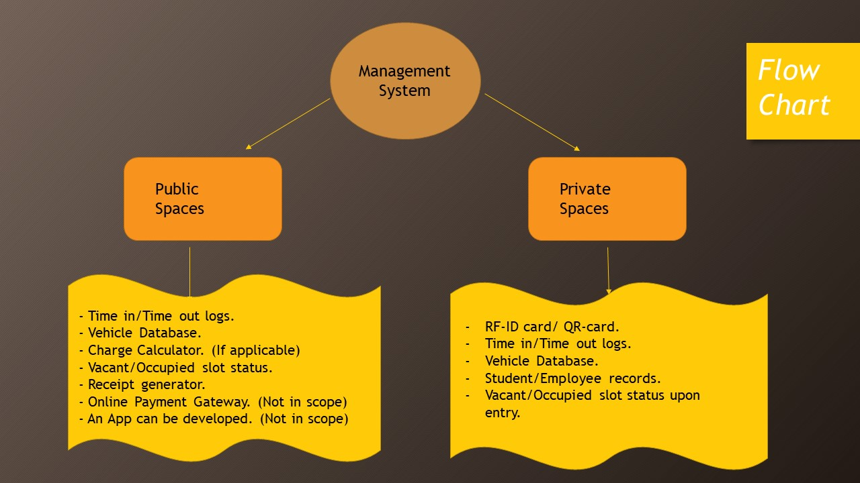

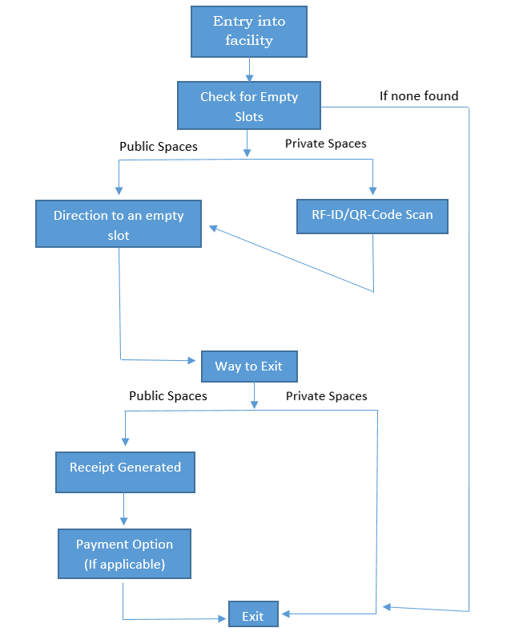

* ***E-R Diagram and Database Design:***

This project does not have a complex database design. It would comprise of a single database with a few columns. This again would be dependent on the need of the organization, using this system. Please note, this is the proposed database design and further changes could be made as we continue our work on the project in the next semester.

* **User_Details ( To store details relevant to a user)**

|  |  |  |
| --- | --- | --- |
| ***Field Name:*** | ***Data Type:*** | ***Description:*** |
| **User_id** | Varchar(10) (foreign key) | ID of customer |
| **Company_id** | Varchar(20) | Name of company (private spaces) |
| **Parking_Slot_id** | Numeric(6,0) (foreign key) | ID of slot allocated |
| **User_name** | Varchar(20) | Name of customer |
| **User_contact** | Numeric(10,0) | Owner’s contact number |

* **Parking_Details (Details related to a particular slot)**

|  |  |  |
| --- | --- | --- |
| ***Field Name:*** | ***Data Type:*** | ***Description:*** |
| **Parking_Slot_id** | Numeric(6,0) (foreign key) | ID of slot allocated |
| **Parking_Slot_Type** | Varchar(5) | Depending upon COV |

* **Vehicle_Details (Details related to a particular vehicle)**

|  |  |  |
| --- | --- | --- |
| ***Field Name:*** | ***Data Type:*** | ***Description:*** |
| **Vehicle_Type** | Varchar(5) | COV |
| **Reg_No** | Varchar(8) (foreign key) | Registration Number of a vehicle |
| **User_id** | Varchar(10) (foreign key) | ID of customer |

* **Receipt_Generator (Details to be printed on receipt)**

|  |  |  |
| --- | --- | --- |
| ***Field Name:*** | ***Data Type:*** | ***Description:*** |
| **Method_payment** | Varchar(10) | Card, Mobile Wallet, Cash etc. |
| **Final_amount** | Numeric(5,2) | Amount to be paid (if applicable) |
| **Time_Occupied** | Date | Time for which slot remained occupied |

* **Time_log (Details pertaining to time in/out etc.)**

|  |  |  |
| --- | --- | --- |
| ***Field Name:*** | ***Data Type:*** | ***Description:*** |
| **Time_In** | Date | Time of entry |
| **Time_Out** | Date | Time of exit |
| **Date** | Date | Current Date/DOW etc/time etc. |
| **S_id** | Numeric(4,0) | Serial Number generated for a car |
| **Reg_No** | Varchar(8) (foreign key) | Registration Number of a vehicle |

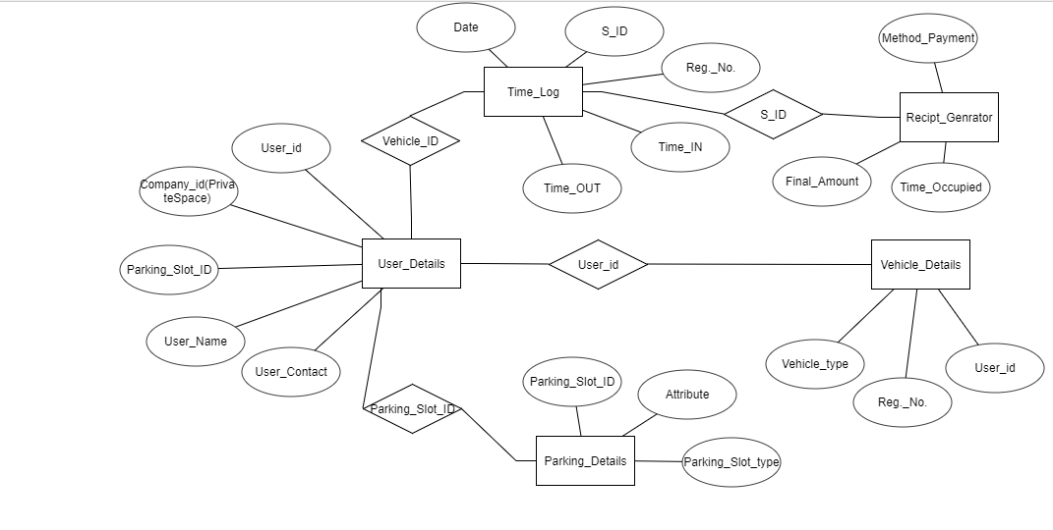

* ***Hardware and Resources Required:***

Based on our studies up till now, we will need the following hardware/materials:

* Raspberry pi-3, sensors(detectors), programming base(Java or C++), other misc. items have not yet been accounted for,
* A computer and display sources (if needed).
* User reviews (Survey Conducted).
* The sensors that can be used for detection purposes are: VIP sensors, Infrared sensors, Ultrasonic detectors, Piezoelectric (High accuracy), Photoelectric (Light source is used), Inductive loop detectors, Magnetic detectors.
* We found Infrared sensors to be the most economical, other sensors can also be used to improve accuracy, but that would depend upon the budget of the organisation, implementing the system.
* ***Timeline and Proposed Workflow:***

The proposed workflow is as follows. However, each individual member has had his hearsay in all discussions regarding the project and their views had been accounted for.

* Preet Merchant - Gathering resources/core working
* Deep Patel - DBMS
* Harsh Patel - DBMS
* Jigyasa Kashyap - Presenting the work in form of ppt
* Divit Vasu - Hardware integration and coding
* Anand Agrawal - gathering data and assisting in ppt

Below is the timeline according to which we worked in this semester:

**Week 1 (4/7/2017) -** Brainstorming session.

**Week 2 (11/7/2017) -** Project Definition Search/Brainstorming.

**Week 3 (18/7/2017) -** Analyzing Project Topics from each group member and

Deciding onto the final Project Topic.

**Week 4 (25/7/2017) -** Searching for references on the web.

**Week 5 (8/8/2017) -** Respective tasks were assigned to the group members.

**Week 6 (22/8/2017) -** Assigned tasks were worked upon.

**Week 7 (29/8/2017) -** Questionnaire for survey was designed.

**Week 8 (5/9/2017) -** Survey was conducted.

**Week 9 (12/9/2017) -** Survey results were analyzed.

**Week 10 (19/9/2017) -** Flow chart was worked upon and made.

**Week 11 (26/9/2017) -** Database design and E-r diagram were finalized.

**Week 12 (3/10/2017) -** Final project report was created.

* ***Survey Form And Analytics:***

Please find the survey form and survey analytics attached at the end of the report.

* ***Bibliography:***
* <https://docs.microsoft.com/en-us/azure/sql-database/sql-database-develop-cplusplus-simple>
* <https://www.codeproject.com/Questions/341111/How-to-connect-SQL-Server-to-Cplus-Program>
* <https://www.quora.com/How-do-I-connect-SQL-with-c>++
* <https://stackoverflow.com/questions/13971156/how-to-connect-to-sql-server-in-c>
* <https://www.techhowtos.com/programming/how-to-connect-to-sql-server-from-visual-c-plus-plus/>
* <https://dev.mysql.com/doc/connector-cpp/en/connector-cpp-examples-complete-example-1.html>
* <https://www.crazyengineers.com/threads/database-connectivity-using-c-c-tutorial.23155/>
* <https://www.youtube.com/watch?v=4Wv3YNjchts>
* <http://ieeexplore.ieee.org/document/7440708/>
* <http://ieeexplore.ieee.org/document/1468953/?reload=true>
* <http://hackaday.com/2016/02/28/introducing-the-raspberry-pi-3/>
* <https://opensource.com/life/16/3/how-configure-raspberry-pi-microcontroller>
* <http://www.techradar.com/news/software/learn-to-program-your-raspberry-pi-1148194>
* <http://www.raspberry-projects.com/pi/programming-in-c/getting-your-raspberry-pi-ready-for-c-programming>
* Some books as ready reference
* Prof. Mitul Patel
* Prof. Hirav Shah
* Google Forms (Survey)

*End of Report.*